Instructions
This template is designed to help Facilitators and schools write a School Travel Plan by compiling information in one place, as it is collected or created throughout the School Travel Planning (STP) process. Guidance notes are included as comments throughout this template. Yellow highlighting signifies text holders to be filled in or note sections to be deleted. No highlighting or guidance notes should remain in the final product.

Sections of School Travel Plan Document
A School Travel Plan contains the following components. See page 4 of the Guide for Facilitators for a table showing the timing of completion for each part.
- Cover Page
- Edition Tracking (new)
- Team & Endorsement
- Table of Contents
- Introduction
- School Profile
- Overview of Timeline
- Vision & Targets
- Data Collection—Summary of Findings
- Travel Challenges Summary
- Action Plan
- Implementation Highlights
- Appendix: Detailed Timeline



<School Name>
School Travel Plan

<Edition # & date it was finalized>

<insert school photo or student artwork>

<Insert other logos here>

Edition Tracking
Edition # | Description | Date Finalized
1 | Official launch of School Travel Plan including endorsement signature(s) | October 31, 2018
2 | Updated to include results of first round of follow-up data collection and implementation tracking to date | June 1, 2019
3 | Updated to included second round of follow-up data, implementation tracking to date and revisions to the Action Plan | October 26, 2019
… | … | …

Team & Endorsement

Committee Members

School STP Committee
- Insert a complete list of committee members—include name and job title or stakeholder type, e.g., student, parent, community volunteer

Regional STP Committee
- Insert a complete list of committee members—include name and job title

Endorsement
I endorse the contents of this School Travel Plan:
SCHOOL PRINCIPAL, ON BEHALF OF THE SCHOOL STP COMMITTEE

Name: ___________________________________

Signature: ___________________________________

Date: ___________________________________

LEAD REPRESENTATIVE OF THE REGIONAL STP COMMITTEE

Name: ___________________________________ Job Title: ___________________________________

Signature: ___________________________________

Date: ___________________________________

Table of Contents

Introduction 1
School Profile 3
Overview of Timeline 7
Vision & Targets 8
Data Collection—Summary of Findings 10
Travel Challenges Summary 12
Action Plan 13
Implementation Highlights 14
Appendix 1: Detailed Timeline 15

Introduction
School Travel Planning (STP) is a community-based approach for increasing rates of active school travel. (Active school travel refers to transportation using human-powered modes such as walking, cycling, scooting, skateboarding and rollerblading.) Staff, parents and students at our school worked with stakeholders at the regional level to create this School Travel Plan document. We are working together to:
- increase the number of children using active modes of transportation to and from school;
- decrease traffic congestion at the school; and
- increase the proportion of ‘bus zone’ students who regularly ride the school bus.
We will revisit and update this document on a regular basis, adapting our Action Plan as necessary and tracking implementation and data collection results.

The STP Process
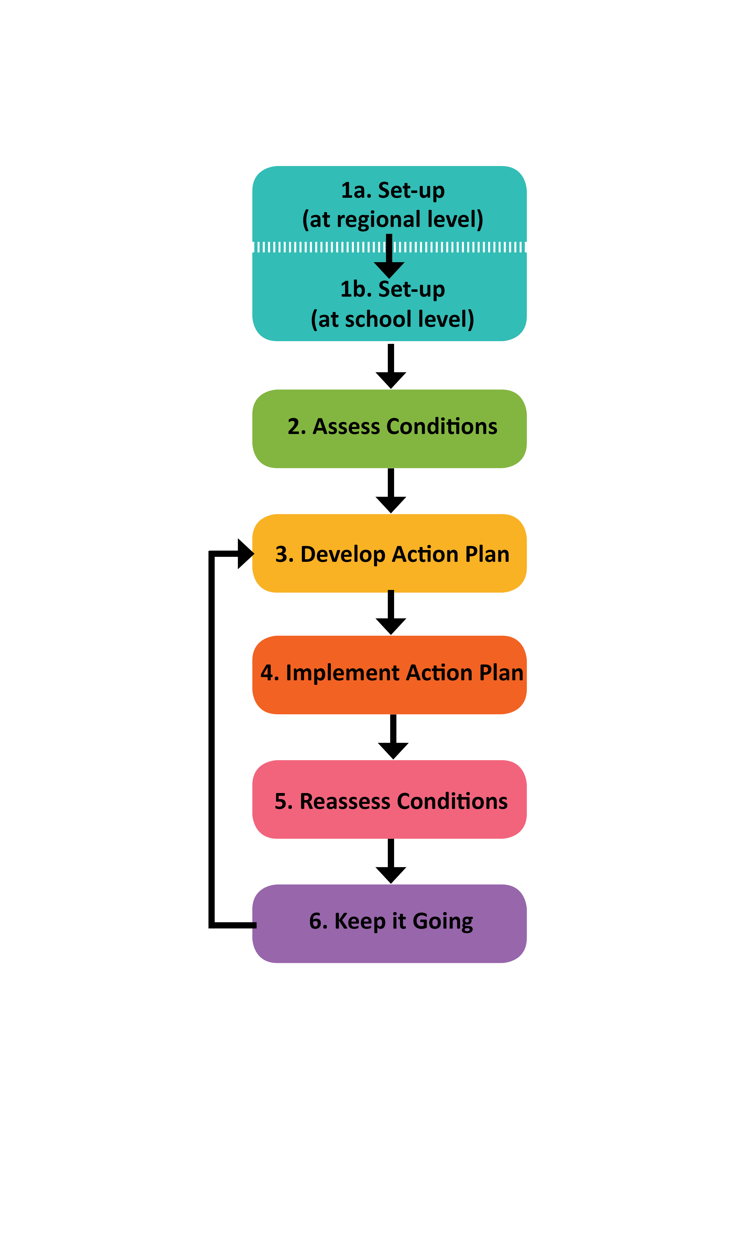
Green Communities Canada maintains the STP Toolkit online at
www.ontarioactiveschooltravel.ca/school-travel-planning-toolkit.

Background
[Insert any relevant local background information about student transportation, active school travel and STP, at the regional and school level]

School Profile
Date form completed: <date>
School name
School type | □ Public  □ Separate  □ Private  □ Other ______________________________________
Year opened
Name of school board
Total number of students
- Students who receive bus service (i.e., who live in the ‘bus zone’) | [# of students who live in the ‘bus zone’: ______ ]  divided by [total # of students: ______ ] =  ______% of students who live in the ‘bus zone’
- Students who live in the  ‘walk zone’ | [# of students who live in the ‘walk zone’: ______ ]  divided by [total # of students: ______ ] =  ______% of students who live in the ‘walk zone’
Grades | □ Elementary (K-6)  □ Elementary (K-8)  □ Middle school (6-8 or 7-8)  □ Secondary (7-12 or 9-12)  □ All levels (K-12)
Bus policy | ‘Bus zone’ definition: minimum # km between school and home for which grades?  _______km_ (for grades: _______)  _______km_ (for grades: _______)

School bell times | Morning: ______________  Afternoon: _____________
Description of location | □ Urban (e.g., city or town centre)  □ Suburban  □ Rural  □ Other: _____________________________________
Socio-economic description of families | % of students who live in lower-income households: ______  % of students whose parents have some university education: _______
Special programs at this school that may impact choice of travel mode | □ French immersion □ Extended French  □ Fine arts □ Special needs: _____________  □ Before and after school day care  □ Other: _____________________________________
Existing transportation facilities at school site | □ Bike racks/storage (# bike spaces: _______)  □ Car parking lot (# car spaces: _______)  □ Kiss n ride  □ School bus drop-off zone  □ School crossing guards  □ Adult or student safety patrol  □ Public transit bus stops serving school  □ Transportation arrangements to after school programs  □ Crosswalks  □ Sidewalks  □ Other: _______________________________________
Existing safety education resources | □ Traffic safety education—if so, who provides it, to what grades and how often? _______________________________  __________________________________________________  □ Pedestrian safety education—if so, who provides it, to what grades and how often? _______________________________  __________________________________________________  □ Bike safety education—if so, who provides it, to what grades and how often? ____________________________________  __________________________________________________  □ Police officer school liaison  □ Anti-bullying education—if so, who provides it, to what grades and how often? _______________________________  __________________________________________________  □ Hydro safety education (power lines and hydro fields) —if so, who provides it, to what grades and how often? ___________  __________________________________________________  □ Other: __________________________________________  __________________________________________________
Programs at this school that have goals similar to STP | □ Ontario EcoSchools certification (level: ________________)  □ Environmental program (specify: _____________________)  □ Physical activity program (specify: ____________________)  □ Mental health program (specify: _____________________)  □ Other: __________________________________________

Types of school/parent committee communications used/available  (e.g., newsletter, website, Facebook page) | □ School newsletter (electronic or paper)  □ School Council newsletter (electronic or paper)  □ Automated mass voicemail  □ Website  □ Twitter  □ Facebook  □ Other: __________________________________________
Languages used in school communications
Languages that would aid communication with parents (if resources permit)
Is the school in a Neighbourhood Watch or Block Parent community? | □ Yes  □ No
Other information

Map of school area

<Insert school area map here: If possible, obtain a dot map that shows where students live as well as the school location and catchment area border>

Overview of Timeline
[Note: This table will summarize your planned dates for each STP phase. Appendix 1 contains a detailed timeline you can use to track your planned and actual dates for specific tasks within each phase.]
 | Plan
Task | Start Date | End Date
Phase 1b: Set-up at school level
Phase 2: Assess conditions
Phase 3: Action planning
Phase 4: Implementation
Phase 5: Reassess conditions
Phase 6: Keep it going

Vision & Targets

Vision
[Insert your vision statement here: see Phase 2 Task 6 (page 28) in the Guide for Facilitators for instructions about how to brainstorm then write a vision statement to guide your STP work.]

High-Level School Travel Planning Goals
The main goal of School Travel Planning is to get more students to use active school travel (AST). One way to increase the number of students walking and wheeling is to reduce congestion and increase safety at the school site, so that is another key goal for the work. The diagram below shows how all the high-level goals of this work fit together. Our School Travel Plan has been created with these high-level goals in mind, i.e., it contains a comprehensive Action Plan that addresses engineering, education, enforcement, encouragement and evaluation so that all of these goals are supported.
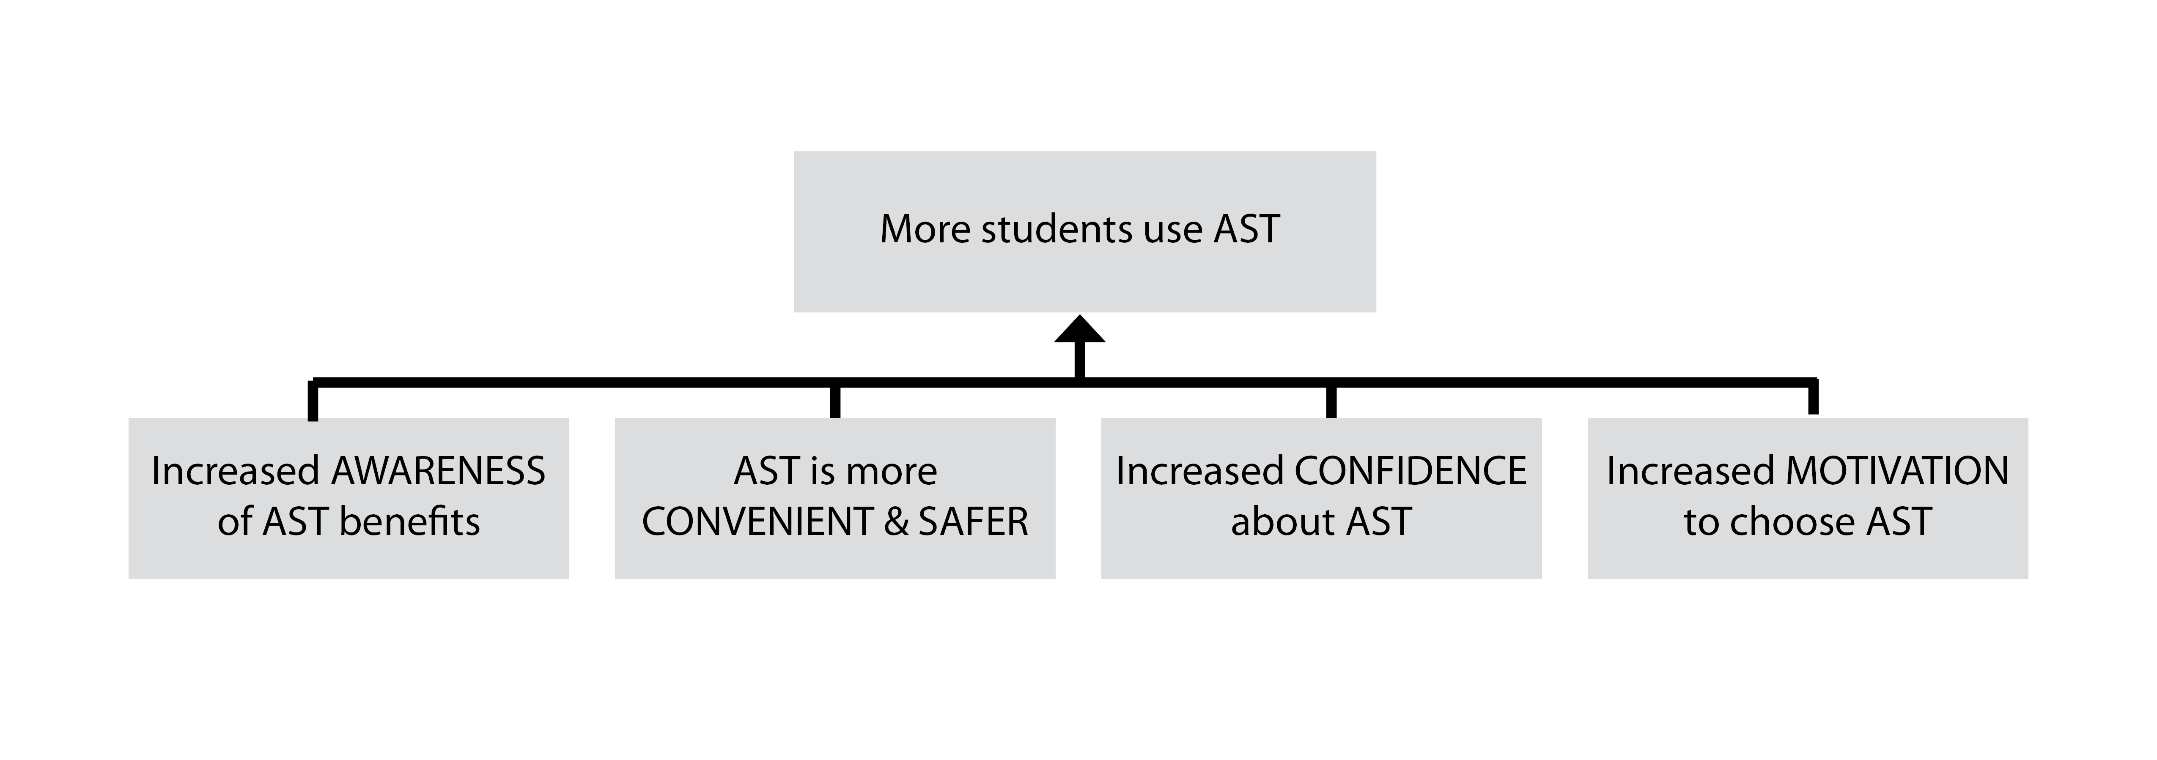

Key Targets for Our School
The table below shows our key baseline metrics as well as short- and long-term targets we have set.
Metric | Baseline # (month/year) | Target #  (after 1 yr) | Target #  (after 2 yrs) | Visionary Target #  (after 10 yrs)
Walking Metrics
% of students in the ‘walk zone’ who walk TO school | <insert your baseline data from Phase 2> | <insert your targets>
% of students in the ‘walk zone’ who walk FROM school
Cycling Metrics
% of students who cycle TO school
% of students who cycle FROM school
# of bikes in the bike rack(s)
School Bus Metrics
% of students in the ‘bus zone’ who ride the school bus TO school
% of students in the ‘bus zone’ who ride the school bus FROM school
Private Vehicle Usage Metrics
% of students who get a ride TO school in a private vehicle
% of students who get a ride FROM school in a private vehicle
# vehicles entering the school parking lot at start of school day
# vehicles entering the school parking lot after school
# of vehicles using the Kiss n Ride
<add other metrics as required>

Data Collection—Summary of Findings
Refer to the timeline in Appendix 1 for details about which data collection tools were used at which times.
INSTRUCTIONS:
In the first edition of your School Travel Plan, this section will include a summary of your baseline data collection findings. At a minimum, you will likely want to include:
- Graphs or a table showing school-wide average results from your Student Travel Survey, e.g.,
  - % of students using each mode of transportation, with the total adding up to 100% (perhaps shown in two pie charts, one for to school and one for from school)
  - % of students in the ‘walk zone’ who reported walking (to versus from school)
  - % of students who reported cycling (to versus from school)
  - % of students in the ‘bus zone’ who reported riding the school bus (to versus from school)

Remember, findings from the Family Survey, Traffic Observation and Walkabout will inform the contents of the “Travel Challenges Summary” (the next section). So, you may or may not want to include details about the findings from those tools here.

In later editions of your School Travel Plan, after you’ve collected follow-up data, you will expand this section to show baseline versus follow-up data.

You may also want to create graphs or tables showing your actual baseline/follow-up data compared to targets you have set.

Travel Challenges Summary
The main travel challenges we face at our school are:
<1. Issue + Description + photo (optional) + map (optional)
2.
3.
4.
5.
6.
7.
8.
9.
10.>

Detailed findings from the Traffic Observation and Walkabout can be found as appendices at the end of this document.

Action Plan
This Action Plan describes our planned activities for the short, medium and long term (e.g., 3+ yrs).
It was most recently updated on: <insert date>.
Action/Initiative | Tasks | Person Responsible | Proposed Dates | Resources or Cost | Notes/Implementation Status
Education
Encouragement
Engineering
Enforcement
Evaluation
Other Actions

Implementation Highlights
Below are details about some of the action plan items we’ve successfully implemented so far. For information about the status of our progress on all Action Plan items, see the Implementation Status column in our Action Plan.
<Action Item>

<description and photos>

<Action Item>

<description and photos>

<Name>

<Action Item>

Appendix 1: Detailed Timeline
[Note: The sample table below is populated with common STP tasks. You may also want to include committee meeting dates and event dates.]
 | Plan |  | Actual
Task | Start Date | End Date | Start Date | End Date
PHASE 1b: SET-UP AT SCHOOL-LEVEL
Complete School Profile
Notify school community about the project
PHASE 2: ASSESS CONDITIONS
Conduct Student Travel Survey
Data entry and analysis of Student Travel Survey, and record key highlights in School Travel Plan
Conduct Family Survey
Data entry and analysis of Family Survey, and record key highlights in School Travel Plan
Conduct Traffic Observation
Conduct Walkabout
Write Travel Challenges section of School Travel Plan
(Optional) Collect additional baseline data & integrate findings into School Travel Plan
Finalize Vision & Targets
Share results
PHASE 3: DEVELOP ACTION PLAN
Write draft Action Plan with School STP Committee
Obtain and integrate feedback from Regional STP Committee and finalize Action Plan
Finalize entire School Travel Plan document and get commitment from stakeholders in writing

 | Plan |  | Actual
Task | Start Date | End Date | Start Date | End Date
PHASE 4: IMPLEMENT ACTION PLAN
Widely advertise the School Travel Plan
Track implementation progress and celebrate success
PHASE 5: REASSESS CONDITIONS
Conduct Student Travel Survey
(Optional) Collect any additional data
Integrate data collection findings into School Travel Plan
Update the "Action Plan" and any other sections if necessary, and publish the 2nd edition of the School Travel Plan
Communicate results and lessons learned
PHASE 6: KEEP IT GOING
Build community capacity, i.e., identify school and regional level champions
Hold a final handover meeting with both committees
Have a handover meeting with lead champions

